Ph0/FIH study
Could you walk me through your development plan from lead optimization through dosimetry study? I’d like to better understand the feasibility of pursuing an eIND for a Phase 0 first-in-human imaging study. From our understanding, companies such as Aktis have utilized international sites to generate initial biodistribution and dosimetry data from in vivo studies without a full GLP toxicology package, and subsequently filed a U.S. IND. Are you planning to follow a similar strategy? If so, where would your approach be aligned or differentiated?
We have a Ph0 study plan that is highly innovative in allowing the evaluation of multiple candidate molecules and collection of full dosimetry data. This will greatly improve the probability of success of the program. The study will initiate in geographies that have regulatory frameworks for microdosing imaging trials that do not require GLP tox or cGMP precursor (e.g. South Africa and Australia). The US sites will start either in parallel under eIND or start once the lead candidate has been selected. The decision on which route to take in the US is dependent on the outcome of an INTERACT meeting with the FDA to clarify requirements for eIND in July 2026.
Study Design: The study runs two sequential cohorts: (i) a Candidate Selection Cohort of 3 patients per peptide across 3–5 candidates, evaluated against pre-specified criteria for tumor uptake and retention, organ-at-risk washout, and predicted absorbed doses; (ii) a Candidate Dosimetry Cohort of 6 additional patients per passing candidate to refine dosimetry and select the lead based on actual human data. See the image below.
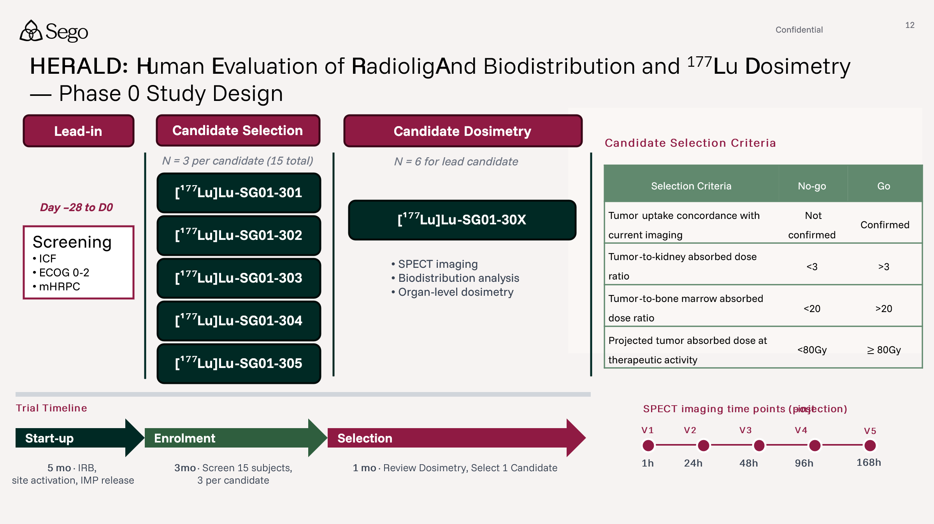
Ex-US Approach: We intend to initiate the Ph 0 program ex-US. Specifically, we are engaging sites in Australia, South Africa and the UK, using similar regulatory pathways as used by Aktis which do not require a full toxicology package or cGMP precursor. Ph 0 initiation at our selected ex-US sites is completely decoupled from any regulatory requirements in the US. In these geographies, a Ph 0 study is not considered a clinical trial, and thus only lighter preclinical packages are required. See the UK MHRA algorithm as an example (link).
US Approach: Rather than filing a full US IND for Ph 1 following Ph 0, we intend to establish US Ph 0 sites. This will enable smoother translation into Ph 1 studies in the US, as FDA requires confirmatory dosimetry on US patients when moving from ¹⁷⁷Lu to ²²⁵Ac, and potentially on demographic grounds. Without the Ph 0 human data the FDA may also insist on starting at lower more relevant starting dose and this can be avoided by gathering US data in Ph 0.
Our Ph 0 approach fits in FDA's Exploratory IND Studies guidance (link), which authorizes microdose imaging (≤100 µg, or ≤1/100th of the no-observed-adverse-effect-level dose) with a substantially reduced nonclinical package, and by FDA's Microdose Radiopharmaceutical Diagnostic Drugs: Nonclinical Study Recommendations (link), which specifies the nonclinical safety package for diagnostic-tracer-level activity. We have submitted an INTERACT meeting request (link - page 5) to FDA to align on which elements of the pharmacology package of the peptide candidates, given the multi-candidate Ph 0 design.
Comparison to Aktis: We are aligned with Aktis in that we will pursue ex-US sites first, using an imaging dose of a therapeutic isotope-labeled peptide (e.g. ¹⁷⁷Lu) and subsequently file a US IND for the therapeutic. However, there are multiple material differences in our approach:
- Lead selection in humans, not mice. Sego runs 3–5 peptide candidates through human Ph 0 dosimetry before locking the lead. Selecting the lead compound in patients rather than from mouse data lets us pick the candidate with the highest tumor uptake and retention, the fastest washout from kidney and other organs at risk, and the widest measured therapeutic index directly, in the patient population we intend to treat.
- We are designing molecules that allow for earlier line use, with a higher bar for safety and more favorable therapeutic index. This means our decision criteria in Ph 0 are strict and ambitious. We want to advance molecules capable of being combined with SOC and delivering more treatment cycles culminating in better PFS and OS without exceeding organ-at-risk exposure/toxicity.
- We will conduct clinical trials where we have control of the inclusion criteria and full access to the data. Aktis conducted IIT (Investigator Initiated Studies), where the PI controlled the patient enrollment and data belonged fully to the site. Our route allows for a more representative patient population of our intended Ph 1 studies.
Sego picks its lead in humans, head-to-head across 3–5 candidates under the same Ph 0 microdose framework, using the metric that is more predictive of patient response and toxicity: measured tumor uptake and retention against measured organ-at-risk dose.
Infrastructure build-out
What are the key considerations driving the need for an in-house manufacturing build-out? How feasible do you view a Plan B in which CMC Stage 1 relies on external CDMOs, with the build-out deferred until proof-of-concept data is generated? Could you also outline the pros and cons of this approach, and how it would impact your budget and development timeline in Plan A (CMC Stage 1 and Stage 2 built) vs Plan B (delayed CMC built until PoC data)?
Vertical integration allows for cost efficiency in early clinical manufacturing, improved efficiency in delivering medication to sites, and synergy with preclinical research needs. Sego is specifically enabled to succeed in vertical integration due to the deep experience of the team in manufacturing across stages of development and the commitment of our founding investors, Wasatch Group. Their investment in Sego includes over $6.5M in TI as part of our building lease, plus an equipment lease which is specifically structured to offset the one-time capital outlay to build a GMP suite ($3M total).
Ph 0 / Ph 1 manufacturing economics favor internal production
Production costs for the planned multi-molecule Ph 0 program are estimated to be $3M at a CDMO vs $1.4M internally. Considering Sego aims to run 6 programs through Ph 0, these costs ramp quickly making in-house capabilities much more cost effective, even when considering a $3M build cost. Below is an example scenario of costs for our planned milestones in 2028/29.
CDMO vs Sego GMP Cost | 2028 | 2029 | 2yr Total
Ph 0 Programs | 2 | 2 | 4
Ph 1 Programs | 0 | 1 | 1
CDMO Development Costs | $4,690,000 | $5,385,000 | $10,075,000
CDMO Production Costs | $1,511,700 | $3,397,700 | $4,909,400
CDMO Total | $6,201,700 | $8,782,700 | $14,984,400
Sego Overhead | $1,187,844 | $1,187,844 | $2,375,687
Sego Production Costs | $472,320 | $1,724,240 | $2,196,560
Sego Build Cost - Net of TI | $1,871,471
Sego Total | $3,531,634 | $2,912,084 | $6,443,718
Savings ($) | $2,670,066 | $5,870,616 | $8,540,682
Savings (%) | 43% | 67% | 57%

Sensitivity: 2-yr Total Savings ($) = CDMO − Sego
Ph 0 ↓ / Ph 1 → | 0 | 1 | 2 | 3 | 4
1 | ($1,382,468) | ($53,388) | $1,275,692 | $2,604,772 | $3,933,852
2 | $1,482,222 | $2,811,302 | $4,140,382 | $5,469,462 | $6,798,542
3 | $4,346,912 | $5,675,992 | $7,005,072 | $8,334,152 | $9,663,232
4 | $7,211,602 | $8,540,682 | $9,869,762 | $11,198,842 | $12,527,922
5 | $10,076,292 | $11,405,372 | $12,734,452 | $14,063,532 | $15,392,612
6 | $12,940,982 | $14,270,062 | $15,599,142 | $16,928,222 | $18,257,302

If only two programs enter Ph 0 the internal build is favorable.
Deferring the Stage 1A GMP build to Series A (Plan B, as above) is not a viable alternative. Standing up a GMP radiopharmaceutical facility takes 12–18 months from commitment to first qualified batch. If Sego starts with CDMOs post-Seed and commits to the build at Series A (targeted mid-2028), the facility would not be ready until late 2029 at the earliest — after the first two Ph0 programs have already run through CDMO, negating the cost advantage shown above and adding the scheduling and tech transfer dependencies the build is designed to avoid. The Stage 1A facility is already in flight and on track for December 2026 completion specifically to be operational before the first clinical manufacturing need in 2028. As discussed, we believe a more realistic scenario would be to delay Stage 2 of the GMP build at the Series A, and instead supply our Ph 3 studies from a CDMO.
We can leverage academic centers in South Africa / Australia to produce doses for trials in their own centers. These sites cannot substitute for GMP manufacturing (or GMP-like manufacturing), which will be required for centers in the US and EU.
Wasatch Group investment is specifically structured to offset build costs
Wasatch has committed $20M in equity and build investment support for the Seed round. $6.5M of the total build costs will be taken as TI within the building lease agreement, offsetting ~40% of the proposed $15M total build cost (the impact of this is shown above as the “Build cost Net of TI”). Further, all scientific equipment purchased, including $2.6M of equipment for the GMP suite, will be structured in an equipment lease, rather than a one-time, full cost outlay for Sego. This keeps our CapEx low, with a marginal increase in operating cost to service the leases. Wasatch has further demonstrated their commitment to Sego’s success by an option in the IRA to another $20M equity contribution to the Series A.
We have the manufacturing experience to operate a world-class GMP facility
This team has built and operated the facilities we are now replicating; that experience compresses the build timeline and reduces execution risk relative to a team standing up RLT manufacturing for the first time.
Greg has taken several radiopharmaceutical diagnostics and therapeutics through clinical development and eventual approval. He has experience in the tech transfer of multiple products to CDMOs and radiopharmacies in the US and EU, including ¹²³I PARPi Tx, ²²⁵Ac SSTR2 Tx, ¹⁷⁷Lu SSTR2 Tx, ¹⁸F PARPi Dx , ⁶⁸Ga PSMA Dx and US approval of ⁹⁹ᵐTc DMSA Dx. Brandon Buckway joins from the University of Utah, where he ran radiochemistry and built out a GMP manufacturing facility. It is one of the few commercial GMP radiopharmacy centers supplying the entire Mountain West and was responsible for being listed as one of the early ANDA/NDA manufacturing sites for several commercial radiopharmaceutical products including FDG, Axumin, Vizamyl, Pylarify, Posluma, and Cerianna. Jeevan was directly responsible for the strategy around scaled manufacturing at Advanced Accelerator Applications (AAA) and at Novartis, including commercial supply for Lutathera and Pluvicto. Richard has translated three ⁸⁹Zr labeled antibody diagnostics to FIH studies via both academic and CDMO manufacturing routes.
Additional strategic advantages of internal GMP supply for Ph 0 / Ph 1
Supply chains are simpler & logistics are derisked when supply is integrated from isotope production to delivery at sites: Placement of manufacturing capabilities near Nusano and the SLC airport allow Sego to maintain full control of isotope delivery and manufacturing scheduling, eliminate decay losses, and reduce scheduling/logistical fragility of the supply chain. In contrast, moving to CDMOs would extend timelines 12 months based on the founding team’s experience of identifying and securing CDMO capacity for six separate RLT programs, completing six independent tech transfers (each requiring analytical method validation at the CDMO site), and navigating CDMO scheduling constraints. Furthermore, we intend several of our clinical sites to be local, including the Huntsman Cancer Center, which is the only National Cancer Institute-Designated Comprehensive Cancer Center serving Utah, Nevada, Montana, Wyoming, and Idaho (10m population).
Simple regulatory approach: Supplying trials from a single site, across stages, keeps regulatory requirements easier to meet. It will be simpler for Sego in the long run.
Synergy with preclinical radiochemistry needs: Hot laboratory infrastructure is differentiating in the preclinical space; few CROs have the capacity to run in vitro or in vivo hot work to high quality. Shared radiation shielding, HVAC, waste handling, and personnel access lower construction cost and ongoing OpEx, as well as molecule supply for preclinical studies. Further, this capital is amortized across all six programs we intend to develop.
4x value premium for RLT companies with manufacturing capabilities: Acquisitions of companies like Fusion, RayzeBio and Point commanded 4x the upfront value vs comparable companies without manufacturing, such as Mariana, 3B Pharma and others. In our experience, big pharma with existing RLT manufacturing capabilities are either looking to diversify their manufacturing footprint or looking to expand capacity. New entrants to the field would be attracted to an end-to-end RLT approach.

Target selection
Note, we have slightly separated out the original question into sub-questions
What advantages do you see in Sego’s target selection strategy that differentiate it from other RLT companies?
Our target selection strategy is differentiated from other RLT companies because (i) it is bespoke to RLT, not simply focused on pulling targets from other modalities (ii) we move beyond pure tumor-specific expression to assess tumor specific accessibility (iii) we focus on novel targets in RLT.
- RLT-bespoke criteria: Our framework is purpose-built for radioligand therapy, not adapted from ADC or immunotherapy target lists, weighting factors like robust tumor expression, internalization kinetics, tumor residency time, and dosimetry feasibility from the outset. We are not lifting targets from the latest hot targets in ADC, but take a first-principles approach in the identification & selection of targets.
- Target accessibility beyond expression: Typically, targets would solely be evaluated for tumor-specific expression. We move beyond this by considering tumor- and tissue-level accessibility, and the accessibility delta for RLT therapies.
- Novel targets with few competing programs: We deliberately avoid crowded areas like PSMA, DLL3 and FAP, and are looking to broaden the level of innovation in the field by pursuing novel targets.
Beyond the six targets discussed (ACP3, KLK2, CLDN1, MUC1-C, CEACAM5, and GCC), has your thinking evolved? Do these remain your highest-priority targets? Are there existing binders that could be in-licensed to accelerate your development?
Our target selection criteria remain unchanged, but our continued interaction with potential collaborators & business partners has highlighted the abundance of in-license opportunities that could accelerate us to the clinic, and the strategic value in de-prioritizing an internal program in favor of an accelerating BD opportunity.
In the last 3 months, we have received inbound from dozens of potential partners and have engaged on 5+ assets either near clinic ready or with FIH data, though ultimately these programs did not meet our internal diligence criteria for in-licensing. We are still evaluating other proposed programs and we are confident that continued search & evaluation is likely to unearth a program that meets our target selection criteria, comes with a strong data package & deal economics, and would accelerate Sego toward FIH entry. We are actively engaged with Chinese RLT companies, European & American academic centers & beyond.
Given the potential for in-license, we have reviewed our six targets in greater detail. We have deprioritized GCC in order to make room for an in licensed asset. This deprioritization is based on GCC ranking in our internal scoring system.
In parallel to our continued outreach, we are leveraging our original 40 evaluated targets, for two reasons: (i) to pre-identify targets we are interested in for S&E efforts, and (ii) to identify a back-up candidate to replace GCC as an internal program, should we not identify an in-licensable program. We are focused on deep diligence of a number of additional tight/adherens junction proteins (e.g. claudins, cadherins, or nectins) and apically expressed targets (e.g. mucins), as these best fit our tumor-specific accessibility paradigm for target selection.
Development timeline
Considering your financing timeline, what is your current timeline for advancing the first two targets to a lead candidate, and subsequently to in vivo biodistribution data? Are there opportunities to accelerate the path to first-in-human dosimetry data given the evolving landscape?
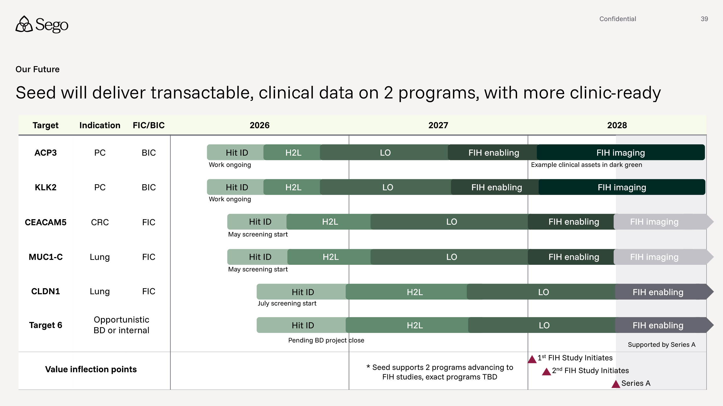
We expect ACP3 and KLK2 to enter the clinic in early 2028, with two primary factors accelerating development: (1) the rational design of molecules based on prior art, e.g. known inhibitors & binders and (2) time and cost-effective approaches to gather gating in vivo data early in our LO/FIH enabling process. Above is the latest timelines & stages on a program basis.
In our experience, rational design approaches are a route to accelerate the identification of tractable, drug-like hits vs. a de novo DEL screens or similar. For ACP3, we are leveraging prior art on this target to drive a multi-tactic accelerated hit finding strategy, vs a longer, de-novo screening approach. This includes structure-based design of small molecule inhibitors, including potential covalent binders, the construction & screening of small, focused peptide libraries, and other routes. For KLK2, families of small peptides have been previously described as broad inhibitors of the kallikrein family. We are leveraging this knowledge in a similar multi-tactic approach for accelerated hit finding, namely structure-based design of KLK2 specific variants and generation of small, focused peptide libraries for screening. We estimate this approach will save us at least half a year vs. other programs without starting points.
Our path to FIH will also be accelerated by smart experimental strategy in our preclinical discovery cascade. In LO, we will leverage ICP-MS to perform multiplexed, non-radioactive PK of lead compounds. This will allow us to quickly triage uptake in tumor and critical organs (e.g. kidney, liver) in a cost and time efficient manner vs. radiolabeling of many compounds for in vivo dosimetry assessment. It will also allow the study of more ligand+linker+chelator combinations in vivo and a clearer understanding of SAR. The best performing molecules will be evaluated for in vivo dosimetry, before selecting 3-5 candidates to advance into FIH imaging studies.
Further, we have matched targets to CROs based on capabilities best suited to the scientific needs of the targets. For example, ACP3 requires extensive small molecule experience and has been initiated at a small molecule CRO vs. KLK2, which will be primary peptide, which has been initiated at a CRO with stronger peptide capabilities. By ensuring best-scientific-fit for each target, we’ll also minimize delays and maximize speed to progress.
With these acceleration opportunities taken together, we forecast both programs entering the clinic in early 2028. Further, we view potential in-license of molecules for other targets (see question above) as adding another route that could get us into the clinic in this seed round.

